**SE LAB ASSIGNMENT-2**

**NAME-SWAPNADEEP MISHRA**

**SEC-A3, ROLL-002211001115**

Consider the program in folder assign2.

**a.Put a breakpoint in 1st executable line of the innermost loop.**

Break d.c:9

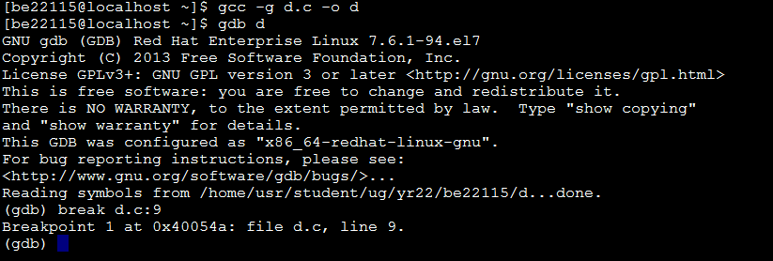

**b. If you run and continue, how many times it is supposed to stop at breakpoint 1?**

c 599999

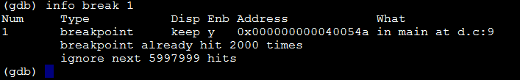

**c. How will you continue so that it stops at 1000th iteration of innermost loop?**

ignore 1 999; run;



**d. How you can condition your breakpoint , so that**

**the loop stops at every 1000 th iteration of**

**innermost loop ?**

condition 1 k > 0 && (k - 999) % 1000 == 0

**e.Put a breakpoint in the 1st line of outermost loop.**

break 6

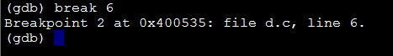

f. Disable breakpoint “1”

disable 1

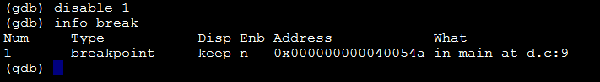

**g. Add a command to breakpoint 2 so that it prints the value of “i” at each hit.**

commands 2 <Enter> print i end

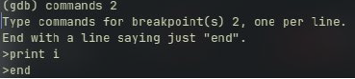

**h. Delete breakpoint 2.**

d 2

